CS-124 MOODBEATS TEAM COURSEWORK 1- & 2-Marks Screenshot Proof Document

Disandu Perera
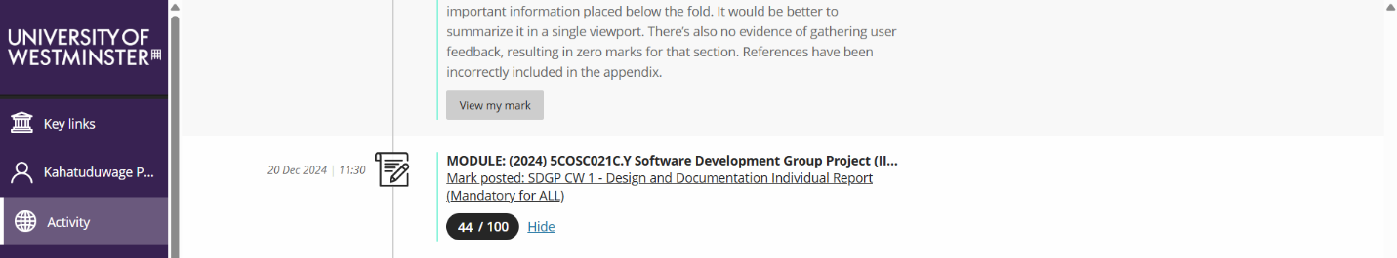
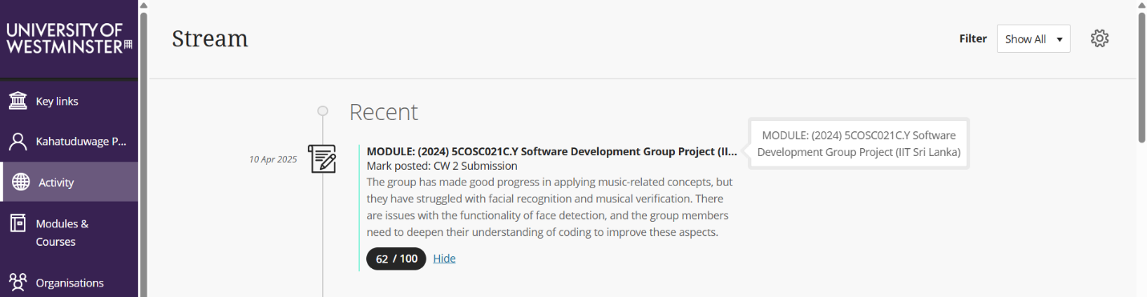
Vihari Ambegoda
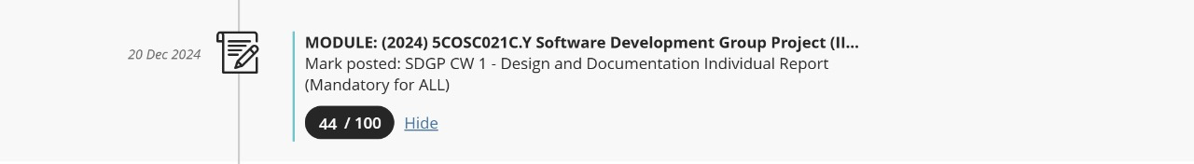
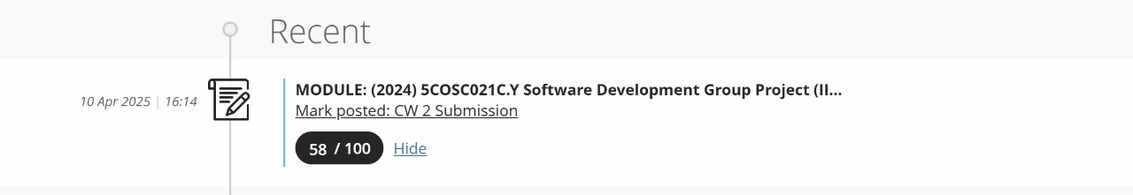
Vidura Baddage
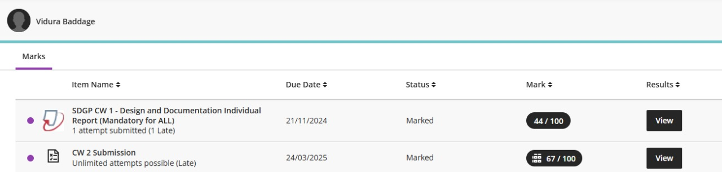

Dineth Jayasuriya
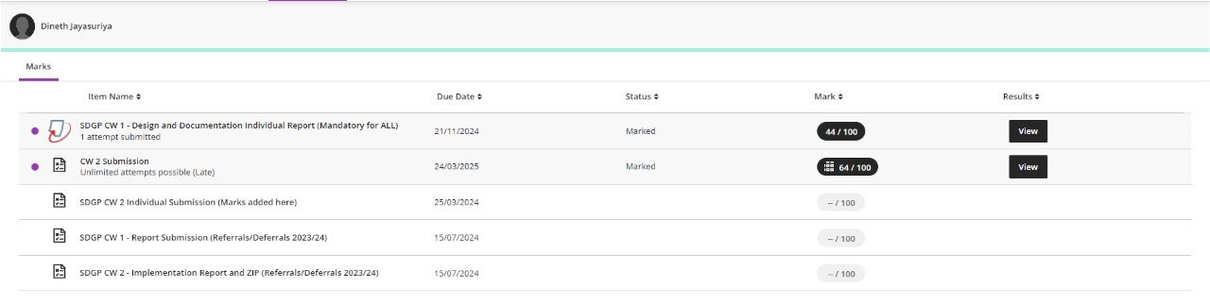
Bihandu Methsilu
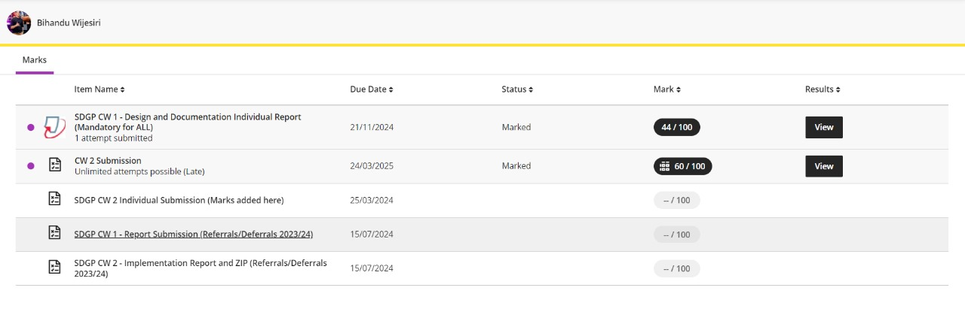
Dilukshan Sothyrajah
